**ONLINE ORGANIC PRODUCT ORDERING SYSTEM**

*Software Requirements Specification*

**Author:** Vaishnavi G

**Version:** 0.1

**Date:** February 6, 2023

1. Objective and scope …...............................................................................x
2. Project End Users …...............................................................................x
3. Features …...............................................................................x
   1. User Login .....................................................................x
   2. User signup …..................................................................x
   3. View and select …................................................................. x
   4. Category …..................................................................x
   5. Home delivery .....................................................................x

4. UML Diagrams -----------------------------------------------------------------x

# **Objective and Scope:**

The objective and the scope of the project is to create an organic product ordering system which would help users to identify and buy a pure organic product easily. The scope of the project includes the following basic features:

* It reduces the manual work of customers of searching the organic products.
* Allow users to login to the application and allow new users to sign up with the system.
* The users can search for variety by giving their choices under the category list.
* The user can reserve the selected product and then fill out address details.
* The user can avail for home delivery around India by paying a charge with personal pickup (cash on delivery).

# **Project End Users:**

Those who need a proper organic product buying and selling system with feature of adding different multiple items in their cart can integrate this system along with theirs.

**Features:**

**User Login:**

The user can login by using their profile name and password. The data will be authenticated, and access will be granted.

**User signup:**

New users can sign up with the system by providing information such as unique profile ID, a strong password. The data will be stored in the database for future login process.

**View and Select:**

The users can view the availability of organic products under menu and select their desired item select their desired product with price and then enter the quantity

**Category:**

Users select their desired product under any category such as skin care products or fertilizers or healthy drinks (only choose one at a time) and then it redirects you to varieties comes under each category with price and then enter the quantity to calculate the total payment.

**Home delivery:**

The users can avail themselves of a home address along with their name and phone number. A delivery charge will be free all-around India, and this system only available in India which can be paid during delivery in person.

**DIAGRAMS**

**USE CASE DIAGRAM:**

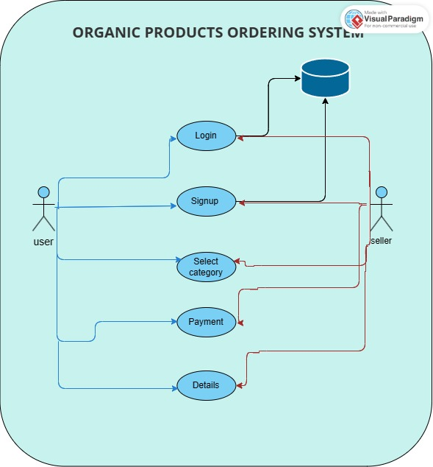

**FLOW CHART DIAGRAM:**

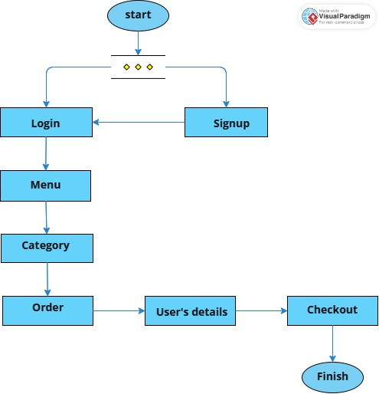

**CLASS DIAGRAM:**

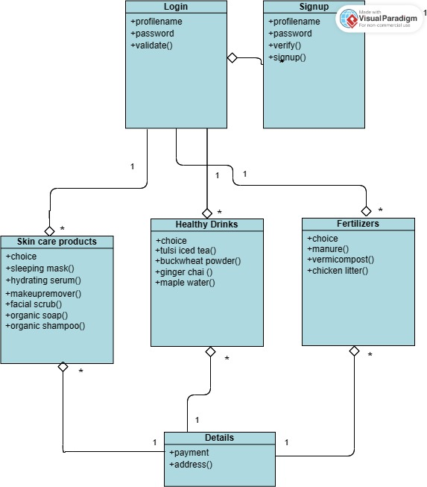

**SEQUENCE DIAGRAM:**

